SLK Assignment Workflow UI
Status: Stable
Last Updated: 10/26/2006 6:47 AM

1. Summary 1
1.1. Related Links 1
1.2. Page Flow 2
2. Document Library Extensions 2
3. Assignment Workflow Pages 4
3.1. Error Handling 4
3.1.1. Message Banner 4
3.1.2. Form Validation Errors 4
3.1.3. Exceptions 5
3.1.4. Query Parameter Errors 5
3.1.5. Common Errors For All Pages 5
3.2. Actions 6
3.2.1. Initialization 6
3.2.2. Page Elements 9
3.3. Assignment Properties Page (APP) 11
3.3.1. Initialization 13
3.3.2. Page Elements (Create Mode) 14
3.3.3. Edit Mode 19
3.3.4. Confirmation Page 20
3.4. Grading 21
3.4.1. Initialization 22
3.4.2. Page Elements 23
3.5. Lobby 30
3.5.1. Initialization 30
3.5.2. Page Elements 31
3.6. Delegate (M3) 34
4. Issues, FAQ and DCRs 35
4.1. Feature FAQ 35
4.2. Proposed Design Changes 35
5. Spec History 35

Summary
SLK supports an assignment workflow similar to that supported by Class Server. Instructors can assign content to learners, who can view and interact with the content online. When learners are done, they submit the content back to instructors, who can review, grade, and return it. In addition to this traditional instructor-led workflow, SLK supports a learner-led workflow where learners can assign content to themselves.

This spec describes the UI for the Assignment Workflow ASPX pages.

Related Links
UI Mockups for this feature are in http://slkdemo/UI Mockups.

Page Flow
The following diagram shows the flow of pages in creation, completion and grading of an assignment:

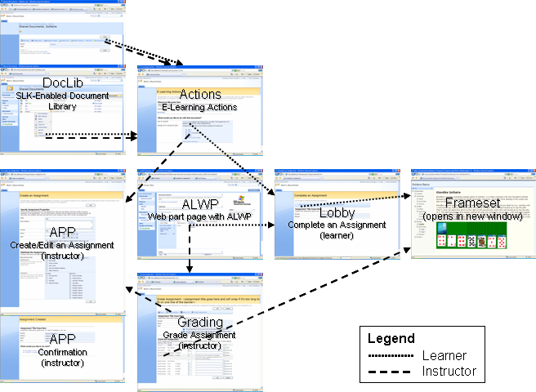

Assignment workflow starts in a SLK-enabled SharePoint document library, where users can choose “E-Learning Actions” from the document context menu. From the E-Learning Actions page, users can assign the document, either to themselves if they’re a learner or to someone else if they’re an instructor. Once the assignment is created, it appears in the Assignment List Web Part (ALWP). From there, learners can access the lobby page to launch the assignment, and instructors can navigate to the grading view for an assignment.

Document Library Extensions
Access to assignment functionality starts in a document library on an SLK-enabled SPWeb. When the SLK feature is activated, the E-Learning Actions item appears on the document library context menu and in the toolbar of the View Properties page:

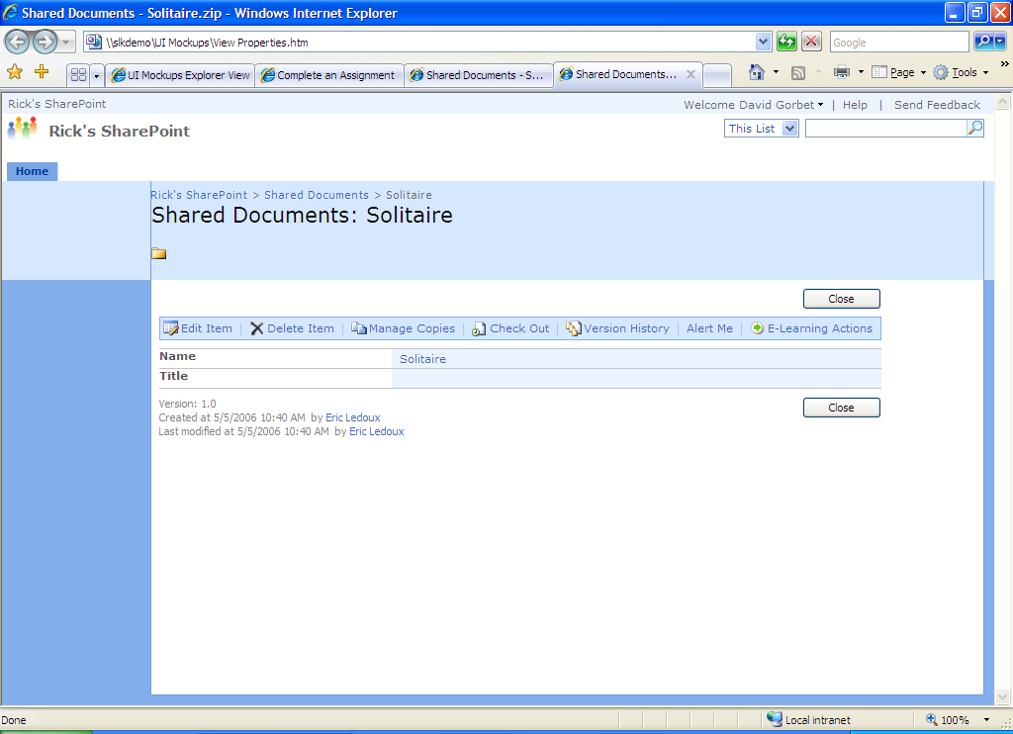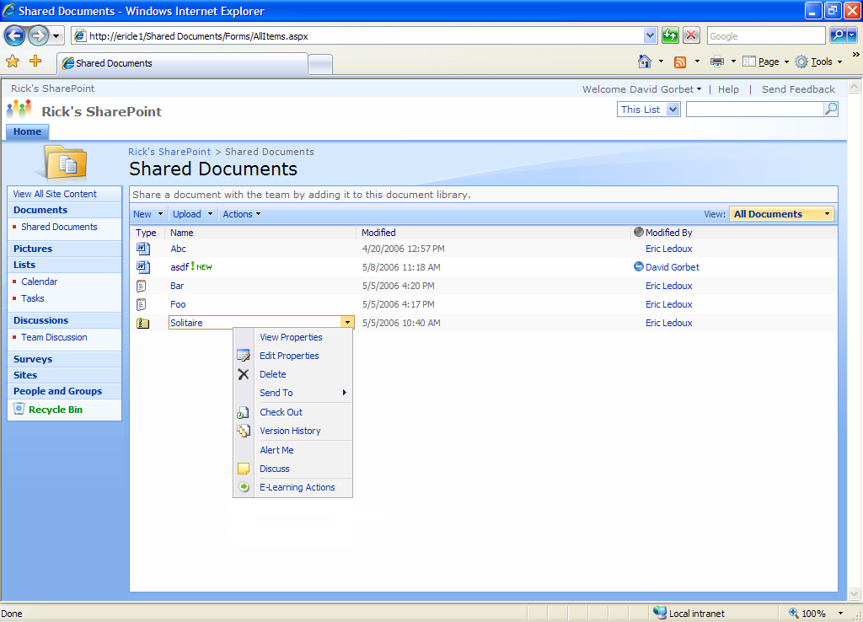
Access to the Actions page.

For consistency with other toolbar links on the View Properties page, only the icon has a tooltip, and the tooltip is the same as the text of the link. Access key for this link is ‘A’ (note uppercase).

Clicking E-Learning Actions either on the context menu or in the toolbar navigates to the Actions page (See Section 3.2), passing in the context of the current file so that the Actions page can retrieve it.

Icons for e-learning content

Because e-learning content is packaged as ZIP files, they use the ZIP file icon. Ideally .lrm, .ims, and .zip files containing an imsmanifest would use an e-learning content icon.

M3 DCRs:

- Add a delete event handler to all SLK enabled doclibs warning the user that deleting content in the doclib will break assignments referencing that content.
- Option: Have the event handler only give a warning if SLK has any assignments referencing the deleted content.
- Have the error displayed to the learner trying to access an assignment without content show the URL to the document to assist with the error.
- Is this a security problem if the current user wouldn’t normally have access to the doclib?
- Allow an instructor in the assignment properties to enter a new URL to the content for that assignment. This allows an instructor to “repair” an assignment if content is accidentally deleted and then replaced with a substantially similar document. (Substantially similar means it would function within the assignment equivalently to the original document with regard to assignment delivery and sequencing and navigation. It would function for attempts already in progress from the previous content.)
- For e-learning content this would need to include warnings that any existing attempts may be broken if the new content does not have similar questions and sequencing and navigation behavior.
- (OSO) Create a cleanup tool to go through the SLK database and delete all assignments that no longer have content.

Assignment Workflow Pages

Error Handling

Message Banner
All of our pages have the ability to render a message banner just below the page description and above any controls on the page. The banner is a <table class="ms-formbody" style="border: black 1px solid">. The banner can contain multiple rows, each with an icon and a message. The message style is ms-formvalidation.

There are three types of messages that can be shown:

Type | Icon | Tooltip for Icon | Recovery
Info |  | Note | Render the rest of the page after the banner and let the user interact with it normally.
Warning |  | Warning | Render the rest of the page after the banner and let the user interact with it normally.
Error |  | Error | No recovery is possible. For all pages except APP and Grading, stop rendering the page after the banner (for APP and Grading, re-render with form fields filled in so that the user doesn’t lose data). User must use nav controls in the chrome or browser controls to recover.

Form Validation Errors
Form pages validate their data before attempting to commit it. All fields are trimmed of leading and trailing spaces, and then validated per the validation rules described in each page’s spec section. If there are multiple validation rules for a single field they are validated in arbitrary order, but in all cases only one message is displayed (validation for each individual field terminates on the first error).

Any validation errors cause the following warning to be rendered in the banner:

There are one or more problems on this page. Additional information is displayed in each section with a problem:

<bulleted list of validation errors>

Example:

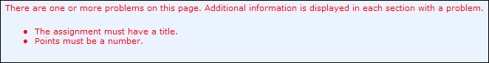

The rest of the page is rendered with all form fields still filled out per user input and the appropriate message is displayed in ms-formvalidation style. Unless otherwise specified, the message is rendered directly below each control that contains an error:

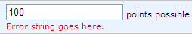

Determining whether a value “is a number”
Several fields (e.g. Points, Final Score) validate that the input is a number. The value is a number if it is any number of digits, preceded by an optional ‘+’ or ‘-’ sign, followed by an optional decimal separator and any number of digits after the decimal. This is embodied in the following regular expression: “^\\s*([-\\+])?(\\d*)\\" + val.decimalchar + "?(\\d*)\\s*$”

Exceptions
Unless otherwise specified, exceptions will be displayed as errors in the message banner if they are safe to display. If they are not safe to display and no other specific message has been specified for the condition in question, display the following error:

An error occurred. More information may be available in the server event log.

Query Parameter Errors
The pages communicate with each other via query parameters. If there are errors in these query parameters, display the following messages in the banner:

Condition | Type | Message
Missing or Empty Query Parameter | Error | “The <param name> parameter is missing or empty.
Invalid Query Parameter | Error | “The value (<value>) is not valid for the <param name> parameter.”

Common Errors For All Pages
Condition | Type | Message
SLK not configured on current SPSite | Error | “This site is not configured to use SharePoint Learning Kit. Administrators can use SharePoint Central Administration to configure SharePoint Learning Kit.”
Current user not signed in | Error | “You must sign in to use SharePoint Learning Kit.”

Actions
A user can choose “E-Learning Actions” from either the dropdown menu or the View Properties page of a document in an SLK-enabled document library (See Section 2). Either choice navigates to the E-Learning Actions page. The page looks like this:

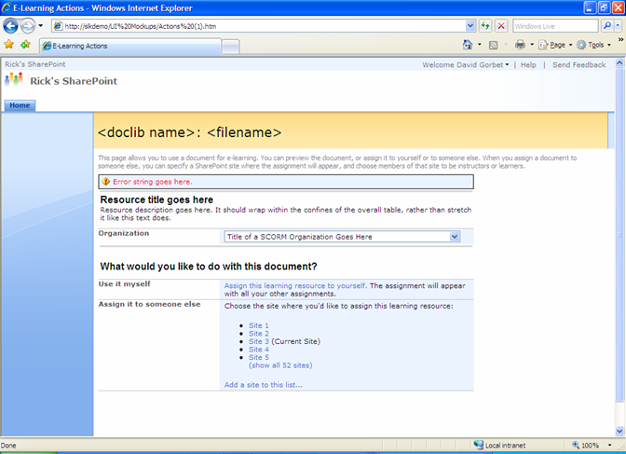

An HTML mockup for the page is available at http://slkdemo/UI Mockups/Actions (1).htm.

Initialization
The Actions Page runs in the context of the site from which it was invoked.

The Actions page is always invoked in the context of a document from a document library. See Section 3.2.1.1 for additional errors and warnings for various states of the document.

What if the file is a new version of an existing file that has already been assigned?

In this case, we consider it a different file and allow creation of a new assignment. Figuring out all the versioning issues and giving the user the option to create a new one or replace an existing one sounds like a v2 feature.

What happens if there is already an assignment for this file?

We considered joining an existing assignment, or listing all current assignments for a given file on the Actions page so you could either create a new one or join an existing one, but this just feels like feature creep for v1. It’s a clean conceptual model that you create a new assignment from the doclib, and you join existing assignments from the ALWP.

Initialization errors
Condition |  |  | Type |  |  | Message
Invalid ListID or ListGUID, or can’t retrieve the document |  |  | Error |  |  | “The learning resource does not exist or you may not have permission to access it.”
ListID refers to a folder, rather than a document |  |  | Error |  |  | “You cannot assign a folder. To assign all the contents of a folder, you must package its contents into a single archive file.”
Versioning not turned on for the doclib, or version numbers limited |  |  | Warning |  |  | “The document library (doclib name) does not have versioning turned on or the number of versions is limited. Editing this learning resource after you assign it could cause unpredictable results.”
Document is currently checked out to current user |  |  | Error |  |  | ”You cannot assign the learning resource because it is currently checked out to you. You must check it in before assigning it.”
Document is a draft, per WSS file versioning spec definition |  |  | Warning |  |  | “The learning resource is a draft. If you assign it, learners may lose access to it once it is published or approved.”
SPWeb is not part of an SLK-enabled SPSite | Error |  |  | “This site is not configured to use SharePoint Learning Kit. Administrators can use SharePoint Central Administration to configure SharePoint Learning Kit.”

Why do we want versioning turned on?

When you create an assignment, we create a package containing the manifest, and we link to the document in the doclib. If for some reason that document gets out of sync with either the manifest in the package or the learner response data in the attempt data model, you could get strange behavior. The safest way to avoid this is to enable versioning on the doclib, because then if you overwrite a document with a new version, as long as the old version still exists, the assignment will work correctly.

Errors self-assigning
Note that you do not have to have the learner permission to self-assign content.

Errors adding a SPWeb to the SPWeb list
When the page posts to add a SPWeb to the SPWeb list, we determine whether the URL corresponds to anything on a SharePoint SPWeb (e.g. a document library, Web Part Page, etc.) and if so, we use that SPWeb. In other words, the URL doesn’t have to point to the home page of the SPWeb; it can point to anything on that SPWeb and we’ll still work.

If there is an error adding the site, then when we re-render we should render with the “Type the address…” box showing, so that the user can see the address s/he typed and correct it.

Condition | Type | Message
Site doesn’t exist, or is not a SharePoint SPWeb, or user doesn’t have permission to tell if site exists. | Warning | “The site (<url>) is not a valid site on this installation of SharePoint, or you may not have permission to access it.”
User doesn’t have instructor permission on the SPWeb. | Warning | "You cannot perform this operation because you are not an instructor on this site (<SPWeb title>)."
SPWeb is already in the list | Info | “The site (<SPWeb title>) is already in your list. Click the (show all sites) link to see your entire list.”
SPWeb is not part of an SLK-enabled SPSite | Warning | “The site (<url>) is not configured to use SharePoint Learning Kit. Administrators can use SharePoint Central Administration to configure SharePoint Learning Kit.”

Why not use inline errors for site validation on the Actions page?

Inline validation errors (next to the control with the error) were designed for cases where there are several form controls, each of which could have an error. In this case, the site edit control is the only control on this page that could have a validation error, so there is no need to go to the expense of adding inline errors.

E-Learning content validation
If the document is e-learning content, it is validated. If validation throws an exception, show the following error message in the banner:

The learning resource is not valid. <exception string if safe to show>

Non-exception validation messages are stored in the database, so that if the document is already cached we can still retrieve them. We do not validate SCORM recommendations; only MLC, LRM and SCORM requirements. If there are any such messages, show the following warning message in the banner:

Some errors in this learning resource were repaired, but the learning resource may not function as expected. (show details...)

Clicking (show details…) on either message causes the page to re-render with the full set of messages in the banner, one per row, with the icon cell empty. Example:

Some errors in this learning resource were repaired, but the learning resource may not function as expected. (hide details...)
- A warning message goes here.
- Another really long warning goes here. This one wraps beyond the boundaries of the message banner because it is so long, but thankfully because we’re using a bulleted list, it isn’t a problem.
- Yet another warning.

Clicking (hide details…) returns the banner to the state before (show details…) was clicked.

Page Elements
Element | Tooltip |  |  |  | Description/Behavior
Page Title |  |  |  |  | The concatenation of the doclib title and the filename, delimited by “: ”. The doclib title should be a hyperlink to the doclib, as it is in the SharePoint View Properties page.
Resource Title | None |  |  |  | If SPFile.Title is not null, use SPFile.Title.  If SPFile.Title is null, then for e-learning content, the title of the resource is drawn from manifest-metadata-lom-general-title (See Section 3.2.2.1 for how to deal with langstrings). If this element does not exist, the filename without extension is used instead. For non-e-learning content, the title of the resource is its filename without extension.  The title is rendered in UserGenericHeader style.
Resource Description | None |  |  |  | For e-learning content the resource description is drawn from manifest-metadata-lom-general-description (See Section 3.2.2.1 for how to deal with langstrings). If there is no <description> it is omitted. If there is more than one description, the first one is used.  Concatenate Description and Instructions  LRM content has both description and instructions. Instructions are stored in a namespaced extension to the manifest. In M3, we should consider concatenating description and instructions if they exist, with maybe a non-localizable separator (e.g. “-----”) between them.  The description is rendered in UserGenericText style.
Organization | None |  |  |  | The row labeled Organization appears only if there is more than one <organization> in the package, allowing the user to choose which <organization> to use. The dropdown contains the <title> element for each <organization> in the order in which the <organization> elements appear in the manifest. If there is no <title>, we use the organization identifier as the title.  The default selection is the one that corresponds to the default <organization>.  The horizontal rules at the top and bottom of the organization row are part of that row, and appear only if the row appears.  If there is only one <organization> in the package, then that organization is considered to be the one selected.
Assign this learning resource to yourself |  | None |  | Posts back to the Actions page to create an assignment with the selected organization, assigned in the context of the current SPWeb. Autoreturn and Show Correct Answers should be true, and the start date/time should be “now”. There should be no instructors on the assignment. When the assignment is created, the page navigates to that assignment’s Lobby page (see Section ). If there were any errors before the transaction that creates the assignment, they are rendered on the Actions page. Errors that happen after the transaction that creates the assignment are rendered on the Lobby page.  For non-e-learning content, the payload of the assignment is simply the file.
Assign it to someone else |  | See Section 3.2.2.2.

Langstrings
When searching for a property value that is a SCORM <langstring> (e.g. <title>, <description>), first search for a <langstring> that has the language attribute that exactly matches both the primary language code and country code of the server. If that does not exist, find the first one that matches the language code. Failing that, return the first one, or if there is none, String.Empty.

Assign it to someone else
This row allows instructors to assign content to learners on any SLK-enabled SPWeb on which they have instructor permissions. To facilitate cross-SPWeb assignment, SLK maintains a list of SPWebs to which an instructor can assign content. There is one such list per instructor. There is no way to remove items from this list, and the only way to add items is as described in Section 3.2.2.3.

Remove SPWebs from the SPWeb list

Time permitting, we should have a UI for removing SPWebs from this list. Can be as simple as a (remove) link or icon next to each SPWeb title, or can re-render with checkboxes and a “remove” button.

When rendering this list, for each entry in the list, verify that the site is still a valid SharePoint SPWeb and that the user has access to it. If not, do not show it in the UI.

When the page initially loads, the bulleted list contains the titles of the n most recently used SPWebs, where n is determined in the SLK settings file (see SLK Settings iSpec for details). The initial default for n is 6. SPWeb titles are listed in alphabetical order. Sites are considered “used” for MRU purposes when an assignment is successfully created on the site.

If the SPWeb from which the content was chosen (the “current site”) is not already in the list, it is added to the bulleted list on this page only (i.e. not added to the list in the database), with the lowest MRU priority. This ensures that it will always be available, but will not displace a more important SPWeb in the list.

The current SPWeb has “(Current Site)” appended to its title.

The tooltip for items in the bulleted list is “Assign the learning resource to learners on site: <SPWeb title>”

Clicking on any SPWeb in the list navigates to the APP page (See Section 3.3) to allow the user to create an assignment on that SPWeb.

Below the MRU list is a “(show all m sites)” link, where m is the total number of SPWebs in the user’s SPWeb list. This link only appears if m is greater than n. Clicking this link re-renders the list with all of the SPWebs in the user’s SPWeb list, listed in alphabetical order, and with the (show all…) link removed.

Adding a SPWeb to the SPWeb list
Clicking “Add a site to this list…” uses DHTML to replace the link with the following UI. Focus should be on the edit control so that users don’t have to click there before typing or pasting their URL:

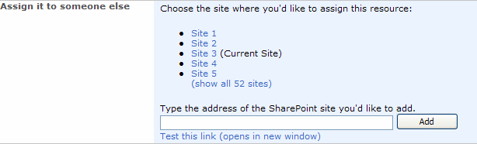

Clicking Add posts back to the Actions page, which validates that the URL in the edit control is a valid SharePoint SPWeb and that the user has instructor permissions on it (see Section 3.2.1.3). If these conditions are met, the SPWeb is added to the user’s SPWeb list in the database with highest MRU priority (so that it shows up in the MRU list). Note that even if the user had expanded this list, when it re-renders it shows the short version again, to help make it easy for the user to find the new entry. When the page re-renders, the SPWeb that was just added has a icon appended to it. This icon lasts only until the next time the page renders, and is intended to help the user find the SPWeb s/he just added.

Clicking “Test this link (opens in new window)” opens a new non-named window to the current entry in the edit control.

If there is nothing in the edit control when the user clicks either Add or “Test this link”, display a client-side alert:

You must type a Web address to add a site to your site list.

[OK]

Assignment Properties Page (APP)
An instructor can access APP either from the Actions page when creating an assignment (Create Mode), or from the Grading page when editing the properties of the assignment (Edit Mode). In addition, when an assignment is successfully created, the page renders as a confirmation page. The Create Mode page looks like this:

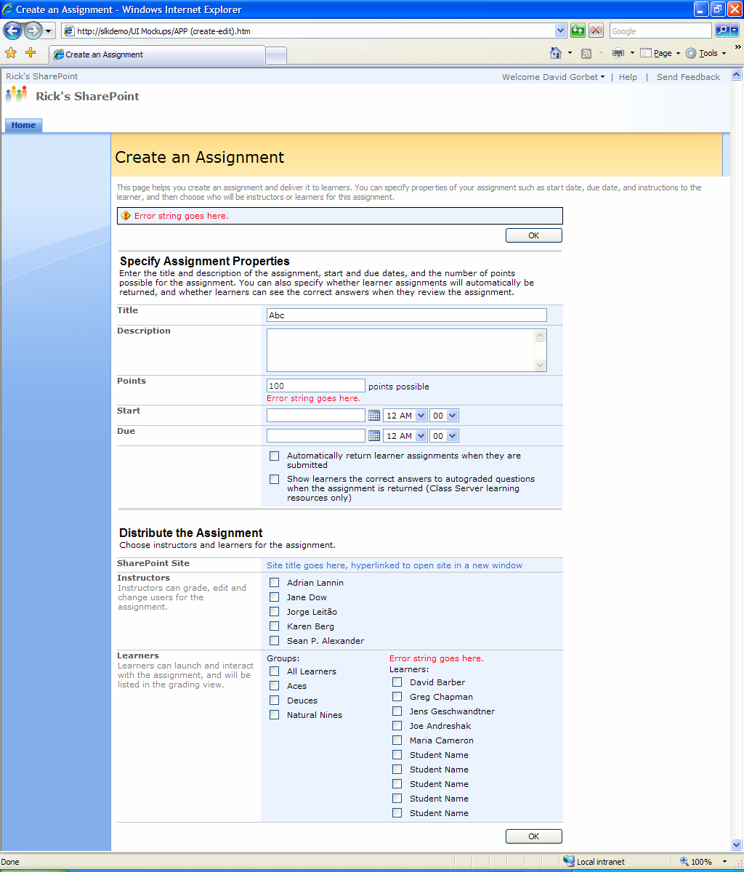

An HTML mockup for this page is available at http://slkdemo/UI Mockups/APP (create-edit).htm.

Initialization
The Assignment Properties Page runs in the context of the site to which the assignment is assigned.

E-Learning content validation
If the document is e-learning content, it is validated as specified in Section 3.2.1.4, except that there is no “(show details…)” link, so the warning looks like this:

Some errors in this learning resource were repaired, but the learning resource may not function as expected.

General initialization errors
Condition |  | Type |  |  | Message
No learners on SPWeb |  | Error |  |  | “There are no learners on this site.”
SPWeb is not part of an SLK-enabled SPSite | Error |  |  | “This site is not configured to use SharePoint Learning Kit. Administrators can use SharePoint Central Administration to configure SharePoint Learning Kit.”

Enumeration errors
If a SharePoint or domain group assigned the instructor or learner permissions encounter an error during enumeration:

- Any group without an error in the group itself or any sub-groups is enumerated per the standard design
- Any group assigned the learner permission with an enumeration error is not added to the learner groups list
- The membership of any group with an enumeration error is not added to the potential instructor/learner lists
- Detailed errors and warnings from the enumeration process are added to a single entry in the server event log
- SLK displays a warning that includes all groups exhibiting an error.

Condition | Type | Message
The membership of a group cannot be enumerated or the enumeration exceeds the 60 second timeout. | Warning | “The list of instructors or learners may be incomplete because the following groups could not be read:  - <Group 1>  - <Group 2>  - <Group n>  More information may be available in the server event log.”

Note enumeration is all-or-nothing for each group assigned the instructor or learner permissions. For example, consider a SharePoint group containing individual users and a domain group. If the domain group encounters an error during enumeration, the page will list the top-level SharePoint group as having the error and none of its members will be enumerated.

Make the enumeration timeout a SLK setting.

In this design, the enumeration timeout value is hard-coded to a reasonably long period of time (60 seconds) to limit the chances of encountering a timeout error. Depending on performance in difference situations, administrators may want a SLK setting to customize the enumeration timeout. Realistically, enumeration processes exceeding one minute will not be useful for instructors, thus, this is added as a DCR.

Create Mode initialization errors
Condition | Type | Message
User doesn’t have instructor permission on the SPWeb. | Error | “You cannot assign to this site because you are not an instructor.”

Edit Mode initialization errors
Condition | Type | Message
Invalid AssignmentID, or user isn’t an instructor on the assignment | Error | “The assignment (ID <assignmentid>) does not exist or you may not have permission to access it.”

Errors creating an assignment
See Section 3.1.2 for general information on how to render validation errors and the Validation column of the table in Section 3.3.2 for validation rules and messages specific to this page.

For validation errors in the Learners row, the error is rendered above the checkboxes:

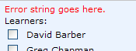

Page Elements (Create Mode)
Element | Tooltip | Default Value | Validation (see Section 3.3.1.6)
Title  Note: Although the edit control for Title looks like a <input type=text>, it is actually a <textarea overflow:visible”> control. This allows for long titles to wrap in the control, rather than expanding the width of the section. | None | If there is more than one organization, a concatenation of the resource title as spec’d in Section 3.2.2 and the title of the selected organization, as follows:  “<resource title> - <organization title>”  If there is no organization title (e.g. the content is non-e-learning content), then do not render the hyphen.  If there is only one organization, then leave the organization title off to be consistent with the title on the Actions page. | Blank: “The assignment must have a title.”  If longer than 1000 characters: “The title exceeds the maximum length of 1000 characters.”  Note: The 1000 character limit is the SPM for the <title> elements in lom
Description | None | The resource description as spec’d in Section 3.2.2. | None
Points | None | For Class Server content, this is the points possible from the LR.  For SCORM 2004 content, default to “100”  For SCORM 1.2 content that did not originate as Class Server content, or for all non-e-learning content, default to blank.  For details on why these defaults, see the SLK Core Concepts spec. | Non-numeric string (see Section 3.1.2.1): “Points must be a number.”  Blank: Not an error (Points is nullable)
Start  This is the SharePoint datepicker control. | Calendar icon has tooltip: “Select a date from the calendar.” | Default to 12:00 am on the current day.  Note: if Start is blank when the assignment is created, start date/time should default to the date/time the assignment was created. | Validate that it’s a valid date, using functionality built into the control. Error text provided by SharePoint.
Due  This is the SharePoint datepicker control. | Calendar icon has tooltip: “Select a date from the calendar.” | Default to blank. | Validate that it’s a valid date, using functionality built into the control. Error text provided by SharePoint.  If non blank and Due <= Start: “The due date must be later than the start date.”
Automatically return learner assignments when they are submitted | None | Default to unchecked. | None
Show learners the correct answers to autograded questions when the assignment is final (Class Server learning resources only) | None | Disabled if not class server content. Default to unchecked. | None
SharePoint Site | “Open site in a new window” | SPWeb title, hyperlinked to open the SPWeb in a new non-named window. | N/A
Instructors | See Section 3.3.2.1. |  | If no instructors are checked: “The assignment must have at least one instructor.”
Learners | See Section 3.3.2.2. |  | If no learners are checked: “The assignment must be assigned to at least one learner.”
OK | Posts the page to create the assignment, logging the creation time in the assignment schema; marks the site as most recently used, and then re-renders as the confirmation page (see Section 3.3.4).

Why not truncate title to fit in our string length limit?

Even if we know the concatenated title will be too long, having the whole thing in the field gives context for the user to choose a title that fits.

Instructors checkboxes
This list is the union of all individuals with instructor permissions and members of groups with instructor permissions, listed in alphabetical order. If a domain group is assigned the instructor permissions, or is a member of a SharePoint group assigned the instructor permissions, then all users in that group and any nested groups are included in the list of potential instructors for that site.

The current user is checked by default, all others are unchecked by default. There are no tooltips.

If the current user is unchecked, display the following alert:

If you uncheck yourself you will no longer be able to grade this assignment, or have access to this assignment’s properties.

[OK] [Cancel]

Learners checkboxes
This is a two-column list. The first column lists “All Learners”, followed by all groups with learner permissions in alphabetical order. Empty groups are not listed.

All domain groups assigned the SLK learner permission directly (not by being a member of an SP group) are treated in the UI similar to SharePoint groups. Each domain group is listed by its SharePoint name and included with all other SLK learner groups in alphabetical order.

Domain groups that are members of a SharePoint group or another domain group assigned the learner permission are not included in the learner groups list because the parent group is listed instead.

Tooltips for groups are of the form:

<Group Name>: <Learner 1>; <Learner 2>; … <Learner N>

There is no tooltip for “All Learners”.

The list of learners is the union of all individuals with learner permissions and members of groups with learner permissions, listed in alphabetical order. This includes members of domain groups assigned the permissions directly or via membership of a parent group with the permissions. There is no tooltip for learner checkboxes.

Won’t domain groups have a large number of users? This design doesn’t really address the scalability of the learners list in the UI.

We often think domain groups have a much larger number of users than SharePoint groups. This has led us to think of treating domain groups differently from other groups in the SLK UI, but there are two main problems with this line of thought:

• SP groups can be just as large as domain groups, especially since SP groups can contain domain groups.
• The current SLK UI is not designed for large numbers of users (> 1000) per assignment regardless of how the users are assigned the SLK learner permission (Domain group, SP group, individually).

This argues for treating domain groups similarly to SP groups and introducing a separate DCR to address ways in which the SLK UI can be changed to support scenarios with large numbers of potential learners and domain groups.

Checkbox Logic
The following state transition table shows what side effects occur on other check boxes when you attempt to check or uncheck any box. Checking or unchecking a box does not result in a new page being sent from the server: all of the logic described below takes place within the browser.

In the Effects section of this table, a “1” means that the checkbox is checked, a “0” means that it is unchecked, and a “—” means that it is not altered.

Attempted Action |  | Effect on the checkboxes
 |  | All Learners | Groups | Learners
All Learners | Check | 1 | All groups: 1 | All learners: 1
All Learners | Uncheck | 0 | All groups: 0 | All learners: 0
A group | Check | — | That group: 1  Other groups: — | Learners in that group: 1  Other learners: —
A group | Uncheck | 0 | That group: 0  Other groups: — | Learners in that group: 0  Other learners: —
A learner | Check | — | Groups for which the learner was the last unchecked learner in the group: 1  Other groups: — | That learner: 1  Other learners: —
A learner | Uncheck | — | Groups containing the learner: 0  Other groups: — | That learner: 0  Other learners: —

Example: For a SPWeb with group membership:

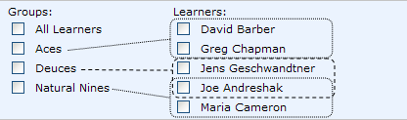

The flow diagram below shows the effect of selecting and unselecting various checkboxes:

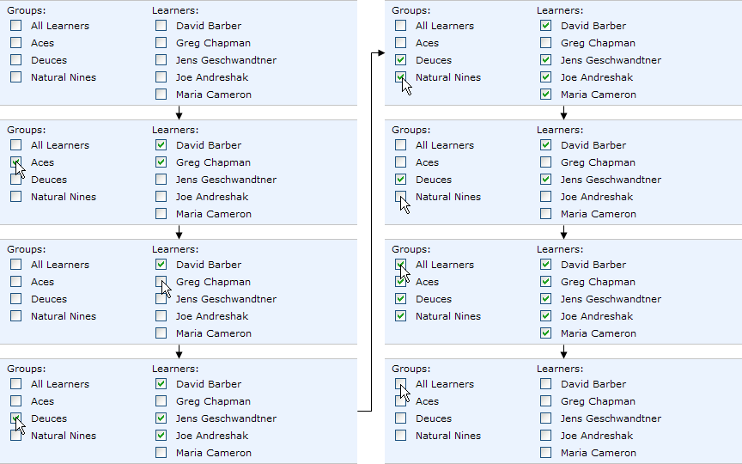

Edit Mode
Edit mode is identical to Create Mode with the following exceptions:
- Page title is “Edit Assignment” for both the title in the <head> element and the visible title on the page.
- Text under page title is “This page helps you edit an assignment’s properties or change instructors or learners for the assignment.”
- The e-learning content validation message defined in section 3.3.1.1 is not displayed.
- All form fields default to the current value of the associated assignment property.
- OK posts to edit the assignment, and then redirects back to the grading page.
- Instructor checkboxes are the union of all instructors on the SPWeb (per Section 3.3.2.1) and current instructors for the assignment. Thus, if an instructor for the assignment no longer has instructor permissions on the SPWeb, s/he is still listed.
- Learner checkboxes are the union of all learners on the SPWeb (per Section 3.3.2.2) and current learners for the assignment. Thus, if a learner for the assignment no longer has learner permissions on the SPWeb, s/he is still listed.
- Instructor checkboxes default to checked for current instructors on the assignment.
- Learner checkboxes default to checked for current learners on the assignment.
- Learner group checkboxes default to checked if all of the members of the group are checked.
- Unchecking learner checkboxes generates alerts (see Section 3.3.3.1).

Instructors without Instructor Permission on the Site
If an instructor accesses Assignment Properties in edit mode and no longer has the SLK instructor permission for the assignment’s site:

- Display checkboxes for all instructors and learners that are currently on the assignment, but do not display potential instructors and learners (i.e. that have “SLK Instructor” or “SLK Learner” permission, but aren’t on the assignment).
- Do not display any groups except “All Learners”.
- Display the following warning in the banner:

Condition | Type | Message
Instructor on the assignment doesn’t have instructor permission on the SPWeb. | Warning | “The available learners and instructors for this site could not be displayed because you are not an instructor on the site.”

Unassigning
In Edit Mode, each checkbox that is checked at initialization time will include in its handler a cancelable alert that will warn the instructor that data will be lost if s/he saves the assignment with the checkbox unchecked:

If you clear this check box, any work completed on the assignment by this learner or group will be permanently deleted.

[OK] [Cancel]

Clicking OK will uncheck the box. Clicking Cancel will leave it checked.

Note: Unchecking a group box (including All Learners) gives one warning for all checkboxes under that box.

Confirmation Page
On successful creation of an assignment, the APP is re-rendered as a confirmation page:

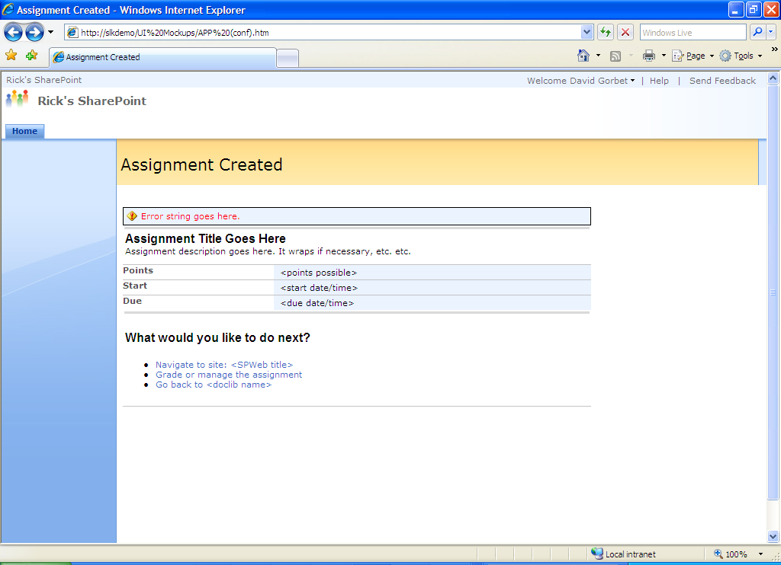

The assignment title, description, and properties are pulled from the assignment object. Start and Due are formatted as “<long date>, <short time>”.

Navigate to site: <SPWeb title> navigates to the URL of the SharePoint SPWeb that was specified in assignment creation.

Grade or manage the assignment navigates to the Grading page for the newly created assignment (see Section 3.4).

Go back to <doclib name> navigates to the folder in the doclib where the content was assigned from. Note that the specific view will not necessarily be preserved. <doclib name> is the title of the doclib.

None of these links have a tooltip.

Grading
An instructor can access the Grading page from queries in the ALWP that show assignments (as opposed to learner assignments) and from the APP Confirmation page. The Grading page looks like this:

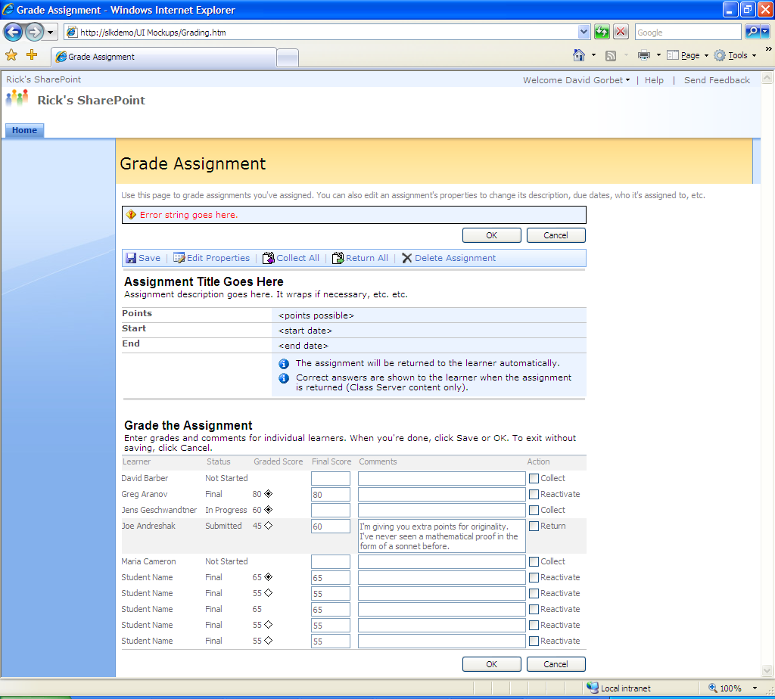

An HTML mockup for this page is available at http://slkdemo/UI Mockups/Grading.htm.

Initialization
The Grading Page runs in the context of the site to which the assignment is assigned.

Redirect to lobby page from grading page and vice-versa

If the ALWP is set up to show assignments rather than learner assignments, then learners who click on the entry will end up at the grading page. Would be nice to redirect them to the lobby page where they should be rather than show them an error. One scenario for the inverse of this would be a query in ALWP that shows all learner assignments for which a user is an instructor. Instructors clicking on the learner assignment should in that case be redirected to the grading page from the lobby page. Since we’re not shipping with any such queries, this is an optional thing to do in M3.

Changes that would have to be made to the spec to support this:
- Add redirect from lobby page as a way to access grading page.
- Change initialization errors so that being a learner or a non-instructor creator of the assignment isn’t an error on the grading page.
- Figure out what happens if the user is both a learner and an instructor. Probably won’t cause a problem, since it will default to whatever page is “right” for the type of item in the ALWP query (i.e. Grading for assignments, and Lobby for learner assignments).

General initialization errors
Condition | Type | Message
Invalid AssignmentID, or user isn’t an instructor on the assignment | Error | “The assignment (ID <assignmentid>) does not exist or you may not have permission to access it.”

Grading post processing
If the form is valid, the data from the form is saved into the respective learner assignments, and the assignment state for each learner assignment whose Action checkbox is checked is transitioned to the appropriate state, and the state transition and timestamp is logged in the learner assignment object.

Note: If multiple teachers are editing the form at the same time, last save wins on a per-row basis (except if the action was for all rows, when of course it clobbers edits from all rows). For example, as long as teachers are editing rows for different learners, they can each save the form and not overwrite each others’ data. If they both edit the same learner row, last one wins.

Condition | Type | Message
Some learner assignments couldn’t be saved | Error | “Some learners' assignments could not be saved: <learners>”, where <learners> is a comma-delimited list of learners whose assignments couldn’t be saved.
Invalid AssignmentID, or user isn’t an instructor on the assignment | Error | “The assignment (ID <assignmentid>) does not exist or you may not have permission to access it.”

Page Elements

Toolbar
The toolbar is rendered using standard SharePoint styles.

Button | Icon |  |  |  | Tooltip |  |  | Behavior
Edit Properties  (accesskey=“I”) |  |  |  | “Edit properties of the assignment, or change instructors or learners (Alt+I)” |  |  | If any Action checkboxes are checked, display the appropriate alert (see Section 3.4.2.6). If OK’d, post back to save the info in the form, and then navigate to the APP page for the assignment.
Collect All  (accesskey=“C”) |  |  |  | “Collect assignments from all learners (Alt+C)” |  |  | Displays the following alert:  Clicking OK posts back to save the grading info, and transitions all learner assignments that were Not Started or In Progress to the Submitted state, regardless of the state of the Action checkboxes.  Clicking Cancel dismisses the alert.
  Collecting assignments will prevent learners from continuing to work on them.
  [OK] [Cancel]
Return All  (accesskey=“R”) |  |  |  | “Return assignments to all learners (Alt+R)” |  |  | Displays the following alert:  Clicking OK posts back to save the grading info, and transitions all learner assignments to the final state, regardless of the state of the Action checkboxes.  Clicking Cancel dismisses the alert.
  All learner assignments will be returned to the learners. If you have not graded all the assignments, some learners may receive zero points.
  [OK] [Cancel]
Delete Assignment  (accesskey=“X”) |  |  |  | “Delete this assignment and all learner work (Alt+X)” |  |  | Displays the following alert:  Clicking OK posts back to delete the assignment, and then navigates to the URL of the site to which the assignment is assigned.  Clicking Cancel dismisses the alert.
  Deleting an assignment will delete all the associated learner data, including learner work and grades for the assignment. You cannot recover deleted information.
  [OK] [Cancel]
Save  (accesskey=”S”) |  |  | If any Action checkboxes are checked, display the appropriate alert (see Section 3.4.2.6). Post back to save the info in the form.
Close |  |  | Navigates to the URL of the site to which the assignment is assigned.

Why not return to the specific page with the ALWP?

To do this, we’d have to pass the page URL from the ALWP to the Grading page. This exposes us to possible phishing attacks. Taking the user back to the site will get them pretty close, and in many cases (when the ALWP is on the site home page) will actually get them back to the right page anyway.

Read-only properties
Assignment title, description, points, start and due are all taken from the current value of the associated assignment property. Dates are in “<long date>, <short time>” format.

Each of the two info messages are present if their associated property is set on the assignment (via the checkboxes on APP). The tooltip for the info icon is “Note”. If neither info message is present, the entire row is removed.

Add filename row

We could add a filename row linked to the doclib folder the file came from, and a (preview) link right next to it to preview the content from grading view. I think this would be useful, particularly if the instructor wants to assign the same content to someone else.

An alternative that would work is to link the filename to the Actions page so you can create a new assignment directly.

Add “copy assignment” functionality

Not sure how you’d do this efficiently; you’d want to link to the APP page to create a new assignment populated with metadata from the existing assignment, but in that case you’d already have to have picked a SPWeb to assign to. Might be better to link to the Actions page (as in the above DCR), but then the properties wouldn’t copy.

Grade the assignment section
This section allows the instructor to access the learner’s work, enter grades and comments for each learner assignment, and advance the workflow state for a learner assignment. Each learner assignment has a row in this table, sorted alphabetically by Learner. The table is not sortable, and the column headers are not links. The row containing the currently active control is highlighted with the ms-highlight style. Each row has the following elements:

Element | Tooltip | Behavior | Validation
Learner | See Section 3.4.2.4. |  | N/A
Status | None | Displays the status of the learner assignment. See SLK Core Concepts Spec for status details. | N/A
Graded Score | “<Computed points with full precision> Points” | Shows the computed points, rounded to two decimals, followed by an icon if the learner assignment success status is known: | N/A
  Success Status | Icon | Tooltip
  Satisfied |  | “Primary objective satisfied”
  Unsatisfied |  | “Primary objective not satisfied”
  Unknown | None | None
Final Score | See Section 3.4.2.5. |  | If non-blank and not a number (see Section 3.1.2.1), display an alert: “The score must be a number.”  Note: It is not an error for Score to be > Points Possible.
Comments | None | Although the edit control for Comments looks like a <input type=text>, it is actually a <textarea overflow:visible”> control. This allows much longer comments; the field will auto-expand as the user types. Width for the comments field should be 200px. | None
Action | See Section 3.4.2.6. |  | None

Learner is the only column that wraps.

Add letter grading capability

This change would allow alpha characters, like A+, B-, etc. to be input in the final score column of the SLK grading chart. Current design only allows numeric final score or the final grade can be null.

A work around in the current design is to set the letter grade in the instructor comments field.

Learner hyperlink
If the assignment has an e-learning payload, the learner’s name may be hyperlinked to open the learner assignment in the frameset. The behavior of this link depends on the state of the learner assignment:

Learner Assignment State | Tooltip | Behavior
Not Started | “The learner has not started the assignment” | No Link
In Progress | “View learner work in progress” | Opens frameset in a new non-named window in Instructor Review View.
Submitted | “Grade learner work” | Opens frameset in a new non-named window in Grading View.
Final | “View and Grade returned work” | Opens frameset in a new non-named window in Grading View.

In all cases, if the frameset is already open for a given learner, don’t open a new window; bring the current window to the foreground.

When the frameset is closed, both Graded Score and Final Score are updated (for Final Score update logic, see Section 3.4.2.5).

Final Score control
This is an <input type=text> control, with width 50px. It is initialized to the computed points value when the learner assignment state moves from ‘Not Started’ or ‘In Progress’ to ‘Submitted’ or ‘Final’, and always shows full precision.

For e-learning content, the behavior of this control depends on the state of the learner assignment:

Learner Assignment State | Tooltip | Behavior
Not Started, In Progress | None | Not displayed in these states
Submitted, Final | “To override autograding, enter a final score here.” | Enabled

In addition, to prevent inconsistencies grading in two places, This field is disabled for Class Server content when the frameset is open to the grading view of the associated learner assignment. When the frameset closes, the delta score is passed back to this page and this field is updated and re-enabled. Note that the handshake must support multiple learner assignments open at a time without getting confused about whose grade is being adjusted.

The rules for updating Final Score are as follows:

Case | Initial State |  | Change in Graded Score while in the Frameset | Final Score after the Frameset closes | Scenario/Rationale
Case | Graded | Final | Change in Graded Score while in the Frameset | Final Score after the Frameset closes | Scenario/Rationale
1 | Blank | Blank | Blank → Blank (no change) | Blank | Teacher assigns Class Server content with no autograded questions. When it’s submitted, she opens it in the frameset, changes nothing, and closes it.
2 | Blank | Blank | Blank → Y | Y | Teacher assigns Class Server content with no autograded questions. When it’s submitted, she opens it in the frameset, grades it, and closes it. Final score should be the graded score at this point.
3 | Blank | N | Blank → Blank (no change) | N | Teacher assigns Class Server content with no autograded questions. When it’s submitted, she gives it a grade before opening it. She later opens it in the frameset, changes nothing, and closes it. The grade she gave should stand.
4 | Blank | N | Blank → Y | N+Y | Teacher assigns Class Server content with no autograded questions. When it’s submitted, she gives it a grade (or is it a grade adjustment?) before opening it. She later opens it in the frameset, grades it, and closes it. When she closes it, we assume that the grade she gave was intended to be an adjustment, and we add the two grades together.  Note that assuming that the initial grade is a delta makes the rules consistent throughout the cases (Except for Case 7, which is a strong special case exception to be symmetrical with Case 2).
4.1 | Blank | N | Blank → N | N+N | Note that this may seem strange, but it’s more important to be consistent. Teachers will learn how this behaves if we keep it consistent.
5 | X | Blank | X → Blank | Blank | Teacher assigns Class Server content with autograded questions. When it’s submitted, the questions are autograded and the grade is copied into Final Score. She then blanks Final Score on the Grading page. Later, she opens the frameset and blanks the individual grades for every question. The Final Score should remain blank.
6 | X | Blank | X → Y | Ask (See Below) | Teacher assigns Class Server content with autograded questions. When it’s submitted, the questions are autograded and the grade is copied into Final Score. She then blanks Final Score on the Grading page. Later, she opens the frameset and either modifies some grades or grades some previously ungraded questions. When she closes the frameset, we don’t know whether she still wants to excuse that student or whether she wants the new grade to override her earlier choice.
7 | X | N | X → Blank | Blank | Teacher assigns Class Server content with autograded questions. When it’s submitted, the questions are autograded and the grade is copied into Final Score. She then adjusts Final Score on the Grading page. Later, she opens the frameset and blanks the individual grades for every question. When she closes the frameset, we blank the Final score, since blanking every single question is a rather intentional action.  Note that this is symmetrical with Case 2.
8 | X | N | X → Y | N+Y-X | Teacher assigns Class Server content with autograded questions. When it’s submitted, the questions are autograded and the grade is copied into Final Score. She then adjusts Final Score on the Grading page. Later, she opens the frameset and either modifies some grades or grades some previously ungraded questions. When she closes the frameset, we update the score, keeping her relative adjustment.

In Case 6, we display the following alert when the frameset closes:

You previously cleared the final score for this learner. Click OK to overwrite the blank score with the new score of <graded score>. Click Cancel to leave the final score blank.

[OK] [Cancel]

Why is Final Score disabled for Class Server content only?

When the frameset is open on Grading View for Class Server content, you can grade in-place. We disable the Final Score box while you’re doing in-place grading so as to avoid conflicts between changes in the grading view and changes on the Grading page. For SCORM content, you can’t grade in-place, so you need to have the Final Score box available while you view the learner’s work so that you can assign a grade.

Allow final score to round

Not sure exactly how we’d work this so it needs to be deferred to M3, but it would be nice if final score could round so that instructors wouldn’t have to worry about autograded SCORM results like 66.666666666666666.

One option (from Mark’s spec): Modify the final score to display a set number of decimal places. To edit the value, the instructor clicks on the number to get an in-place field for editing. The edit field will contain the entire number with all digits. After editing, the user may click away from the field and the displayed number will be updated.

Action checkboxes
Each row of the grading table has an action checkbox that can be used to advance the learner assignment to the next state in the workflow. The label and tooltip of the checkbox reflect the state that the learner assignment would advance to, as follows:

Current State | Next State | Checkbox Label | Checkbox Tooltip
Not Started or In Progress | Submitted | Collect | “Prevents the learner from continuing to work on the assignment, and allows you to grade it”
Submitted | Final | Return | “Returns the assignment to the learner for review”
Final | In Progress | Reactivate | “Allows the learner to re-do the assignment.”

If any reactivate checkboxes are checked when the form is posted for saving an alert is generated:

Reactivating this assignment erases any scoring changes made by the instructors and returns the assignment to the learner to complete again.

[OK] [Cancel]

Lobby
A learner can access the Lobby page by self-assigning from Actions, or by clicking a learner assignment in ALWP. The Lobby page looks like this:

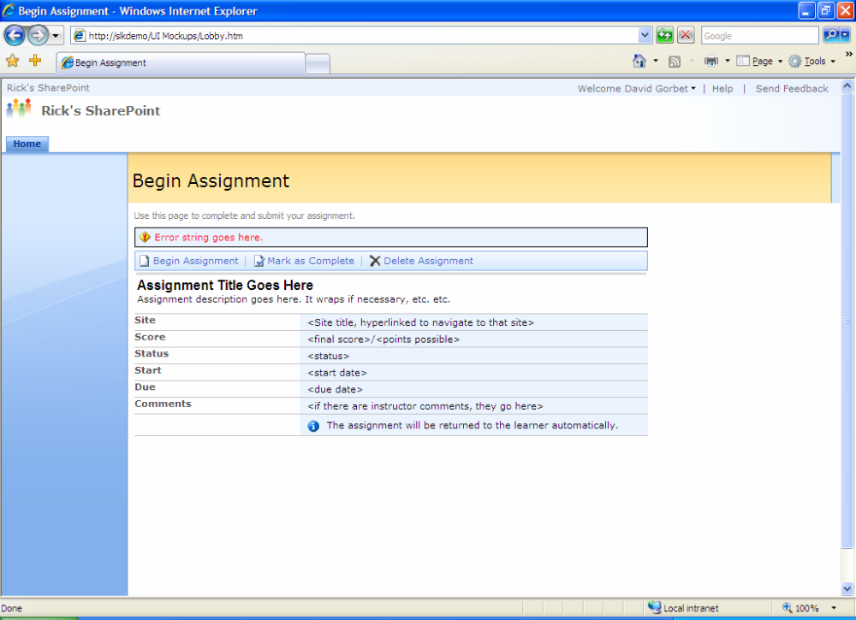

An HTML mockup for this page is available at http://slkdemo/UI Mockups/Lobby.htm.

Initialization
The Lobby Page runs in the context of the site to which the assignment is assigned, unless that site is not accessible to the current user, in which case it runs in the context of the site from which it was invoked.

When the lobby page loads, check if the learner assignment is Submitted, and set to autoreturn. If so, move it to the Final state before rendering the page, logging the state transition and timestamp in the learner assignment object (see Core Concepts spec).

Why do we advance the state here as well as in the content itself?

Two reasons: First, it is possible for the autoreturn flag to be changed after the learner assignment was submitted, either through the UI or through the API. Second, because advancing the state is not part of the same database transaction as finishing the content in the frameset, there is a possibility that one will succeed and the other fail. Having code to detect the inconsistency and advance the state here makes the autoreturn functionality more robust.

General initialization errors
Condition | Type | Message
User is trying to access an assignment on which they are not a learner | Error | “The assignment (ID <assignmentid>) does not exist or you may not have permission to access it.”
SPWeb is not part of an SLK-enabled SPSite | Error | “This site is not configured to use SharePoint Learning Kit. Administrators can use SharePoint Central Administration to configure SharePoint Learning Kit.”

What about errors creating the attempt?

The attempt is actually created in the frameset, not in this page. Errors should be handled there.

Post processing errors
Condition | Type | Message
Learner is marking complete or submitting, but assignment is already in Final state. | Warning | “The current assignment status does not allow the requested action.”

Why isn’t it an error to submit something that’s already submitted?

First, it’s very unusual to have the submit button available if the assignment has already been submitted. It would basically mean that between the time the page loaded and the time the learner clicked the button, something or someone else submitted it (e.g. instructor collected it). In this case, since the net effect is that it has been submitted, we consider the action successful.

Page Elements

Page Title
The title of the page, both in the <head> section and the visible title on the page, should be the same as the text in the Begin/Resume/Review Assignment button. In other words, it should adjust to the status of the learner assignment. If the status is unknown, for example due to an exception, the title should default to Begin Assignment.

Toolbar
The toolbar is rendered using standard SharePoint styles.

Button | Icon | Tooltip | Behavior
Begin/Resume/Review Assignment  (accesskey=“I”) |  | Label, tooltip and behavior depend on learner assignment status. See Section 3.5.2.3.
Mark as Complete  (accesskey=“S”) |  | ”<title of button> (Alt+S)” | Button is only present if there are no instructors on the assignment, and if the learner assignment state is Not Started or In Progress.  Displays the following alert:  Clicking OK posts back to change the assignment state to Submitted, and then re-renders the page.  Clicking Cancel dismisses the alert.
  Once you mark an assignment as complete, you will no longer be able to work on it.
  [OK] [Cancel]
Submit  (accesskey=“S”) |  | ”Submit (Alt+S)” | Button is only present if there are instructors on the assignment, and if the learner assignment state is Not Started or In Progress.  Displays the following alert:  Clicking OK posts back to change the assignment state to Submitted, and then re-renders the page.  Clicking Cancel dismisses the alert.
  Submitting an assignment will send it to the instructor. Once it is submitted, you will no longer be able to work on it.
  [OK] [Cancel]
Delete Assignment  (accesskey=“X”) |  | “Delete this assignment and all learner work (Alt+X)” | Delete is only present if the learner is also the creator of the assignment and there are no instructors for it; learners can’t delete instructor-assigned content from the lobby page, even if they’re the instructor.  Displays the following alert:  Clicking OK posts back to delete the assignment, and then navigates to the URL of the site to which the assignment is assigned.  Clicking Cancel dismisses the alert.
  Deleting an assignment will delete all the associated learner data, including learner work and grades for the assignment. You cannot recover deleted information. Click OK to delete the assignment.
  [OK] [Cancel]

Why don’t we have “Abandon”?

SCORM has two concepts for “done with this attempt” you can complete it or you can abandon it. Although MLC supports both cases, SLK will only support the “complete” case. We considered differentiating assignments that were “collected” by the instructor versus those “submitted” by the learner by setting the state of “collected” assignments to “abandoned” but in the end we felt that the conceptual overhead introducing a new concept was not worth whatever finer grained reporting we would get.

Begin/Resume/Review button
The label, tooltip, and behavior of this button changes depending on the state of the learner assignment:

State | Label | Tooltip | Behavior
Not Started | Begin Assignment | “Begin assignment (Alt+I)” | Launches the frameset in a new non-named window, in Execute view. If the frameset is already open, bring it to the foreground.
In Progress | Resume Assignment | “Resume assignment (Alt+I)” | Launches the frameset in a new non-named window, in Execute view. If the frameset is already open, bring it to the foreground.
Submitted | Review Assignment | “You cannot review the assignment until it has been returned. (Alt+I)” | Disabled
Final | Review Assignment | “Review assignment (Alt+I)” | Launches the frameset in a new non-named window, in Review view. If the frameset is already open, bring it to the foreground.

If bringing the assignment to the foreground fails with a Permission Denied error, display the following alert:

This assignment is already open in another window.

[OK]

Logging

Whenever the frameset is loaded, log an access event in the learner assignment event log (see Core Concepts spec), with the following fields:

- <ID of the current Learner Assignment>
- The current signed-in user
- Begin, Resume, or Review, depending on the state (see table above)
- Current Learner Assignment State
- Current Learner Assignment State
- Current date/time

For e-learning content, after the frameset closes, refresh the page so that the button label is correct and the most recent status information is available.

For non-e-learning content, refresh the button label and status prior to launching the frameset, since the frameset cannot communicate back to the lobby page in this case.

Read-only properties
Site shows the title of the SPWeb to which the assignment is scoped, hyperlinked to navigate to that SPWeb. If at the time of rendering, the user does not have access to the SPWeb, display the following text: “This Web site is not accessible.”

Assignment title, description, start and due are all taken from the current value of the associated assignment property. Dates are in “<long date>, <short time>” format.

If the learner assignment state is final, then Score is the concatenation of the final score and the points possible: “<final score>/<points possible>”. If final score is 0 and the success status of the learner assignment attempt is satisfied, then score displayed is blank. In any other state, Score is “--/<points possible>”. If points possible is null, remove the “/” delimiter.

If there are comments, they are shown regardless of the state of the learner assignment. If there are no comments, the whole row is removed.

Show list of instructors/creator (and maybe other learners)?

Cool if we could have the IM pawns too.

Delegate (M3)
Enable teachers to “clone” themselves and administrators to recover orphaned assignments

Issue: If all instructors for an assignment are no longer around, currently another user cannot manage the assignment. It would be nice to be able to add or replace instructors to assignments in bulk.

One possibility is to provide a UI that does the following:

- List all of the instructors for all assignments scoped to the current site.
- List all of the users on the current site that have the instructor permission.
- Allow the current user (presumably with Full Control permission on the current site) to select an available instructor and add them as an instructor on all assignments associated with an instructor selected in #1.

Ideas for where the UI could live:

This UI could be provided as a page in Layouts that a user needs to add a link or enter the address to the page. It could also be a link in the ALWP or Grading page. (Rick and Mark aren’t big fans of putting a link on ALWP.)

Issues, FAQ and DCRs

Feature FAQ
What if the file is a new version of an existing file that has already been assigned? 7
What happens if there is already an assignment for this file? 7
Why do we want versioning turned on? 7
Why not use inline errors for site validation on the Actions page? 8
Why not truncate title to fit in our string length limit? 16
Won’t domain groups have a large number of users? This design doesn’t really address the scalability of the learners list in the UI. 17
Why not return to the specific page with the ALWP? 24
Why is Final Score disabled for Class Server content only? 29
Why do we advance the state here as well as in the content itself? 30
What about errors creating the attempt? 31
Why isn’t it an error to submit something that’s already submitted? 31
Why don’t we have “Abandon”? 33

Proposed Design Changes
Icons for e-learning content 3
M3 DCRs: 3
Concatenate Description and Instructions 9
Remove SPWebs from the SPWeb list 10
Make the enumeration timeout a SLK setting. 14
Redirect to lobby page from grading page and vice-versa 22
Add filename row 25
Add “copy assignment” functionality 25
Add letter grading capability 26
Allow final score to round 29
Logging 33
Show list of instructors/creator (and maybe other learners)? 34
Enable teachers to “clone” themselves and administrators to recover orphaned assignments 34

Spec History
Date | Changes Made
5/9/2006 | Spec created
5/11/2006 | Added page flow diagram, and spec for Actions page.
5/16/2006 | Added spec for all other pages (changes not tracked), and made the following edits portions of the spec that were already written (changes tracked):  - Moved some common error handling spec to its own section; still more to move.  - Added error condition for self-assigning.  - Added info when adding a site to the site list if the site is already in the list.  - Resource Title and Description now come from SharePoint if possible, and from the content if there is no relevant SharePoint column. This will allow partners to promote metadata and have users change it in SharePoint. Also noted that non-e-learning content gets the title from the filename.  - Specified how (preview) works for non-e-learning content.  - Specified that self-assigned content is in the context of the current site, and has autoreturn and show correct answers turned on.  Still many issues to be resolved, but changing the status to Draft.
5/23/2006 | Major Update to resolve issues and answer dev questions:  Overall  - Refactored the spec somewhat to include doclib extensions in this spec; right now, it’s just a heading—spec for doclib extensions to follow soon.  - Changed warning icon to use diamond-shaped one that is more in the style of our other icons.  - Added FAQ questions and answers throughout the spec, and a FAQ index at the end. Not sure if I’m going to keep this particular organization—we’ll see how it works.  - Made terminology consistent, using “learning resource” (note lowercase) to refer to content that is being assigned, or content in an assignment.  - Noted everywhere where we bring up the frameset, that we pass some information to it (title of the assignment/learning resource, plus name of the learner if we know it). The details of how that happens are left to development.  - Changed all state names to be consistent with SLK states (previously I was using Class Server state terminology). Note that the verbs for transitioning between states are not the same as the states themselves. Verbs are:  - Assign → Not Started  - Begin → In Progress  - Submit/Mark as Complete → Complete  - Return → Final  - Reactivate → Not Started (or is it In Progress?)  - Edited a few alert messages to make them more concise.  - Fixed a few typos.  Actions  - Noted that when adding a site to the site list on the Actions page, you can use any URL that refers to something on a valid SharePoint site, not just the root URL. For example, if you copy/paste the URL to a folder in a doclib, it should still work.  - Added error condition for adding a site and for assigning when the site is not SLK-enabled (i.e. is not on a SPWeb with an associated SLK database. This is not strictly-speaking required to assign in the context of a site, but ALWP on that site won’t work because it won’t be able to find its database, so assigning to such a site is probably an error condition.  - For Title and Description, the first place we look for a title is now SPFile.Title, and because there is no similar concept for description, we no longer look in SharePoint for a description (i.e. we always look in the metadata). This means that if a user wants to change the description of a learning resource, s/he must edit it in the metadata of the file. We provide no mechanism for doing this, but a partner could. I also added a DCR to concatenate description and instructions for LRM case.  - Spec’d how we decide which langstring to use for title and description where they’re stored in a langstring (from Malia).  - Noted that when you add a site to your site list on the Actions page, the page always re-renders with MRU, even if the user had previously expanded the MRU to show all sites. This makes it easier to find the new site, since it’s not crowded in with every single site in your list.  APP  - Noted that we don’t concatenate aggregation title and organization title in APP defaults if there is only one organization, to be consistent with the way the title appears on the Actions page.  - Noted that the Start and Due controls are SharePoint date-pickers (although we’re still not sure we can make that happen).  - In APP Edit Mode, noted that checkboxes default to checked for current instructors or learners, and that group checkboxes default to checked iff all members of the group are checked.  Grading  - Added Collect All to Grading page, and changed icon for Return All to make more sense in light of collect all. Collect All allows an instructor to force all learner assignments to become complete so that learners have to stop working on them. Great for exams or in-class tests, where you want a “pencils down” feature.  - Added more detail to the spec for the learner name hyperlink in Grading. The hyperlink behavior and its tooltip are state-dependant, so that it invokes the correct frameset view. Note that if the learner assignment is Not Started, we can’t invoke the frameset because the attempt doesn’t exist yet.  - Added more detail to the final score control in Grading. It is disabled until the learner assignment is complete, and has an appropriate tooltip to indicate why. Disabling the control until the learner assignment is complete makes autograding logic simpler (we can just tromp over any score in the grading control on the complete state transition). We couldn’t do this in Class Server because we had no way to “collect” assignments. Note also that the final score control is disabled when the grading frameset is open on Class Server content only, so as not to cause conflicts between the grading view and the grading matrix.  - Changed tooltips for the Action checkboxes, and simplified alert situation when actions will be taken on save to only consider reactivate (the only lossy operation).  Lobby  - Noted that the lobby page has to check the autoreturn flag and return the assignment if appropriate. This helps get out of the situation where an autoreturned assignment doesn’t get returned because of a crash during the state transition, but is also necessary for situations where the instructor checks the autoreturn checkbox after some learners have submitted work.  - Added Site property to the lobby page to show the site context of the assignment.  Still to Come  - Spec for doclib changes to initiate e-learning actions.
5/24/2006 | Overall  - Added draft of doclib extensions spec  - Replaced all annotated screenshots with non-annotated ones so as not to alias information from the spec that could get out of date, and made the screenshot resolution higher so you can zoom in and actually read them. I also updates some of the screens that had out of date UA text.  - Noted that on pages where there is a toolbar, we should not render the toolbar in case of a non-recoverable error (as defined in Section 3.1.1) on the page.  - Changed some instances of the word “site” to “SPWeb” to be more explicit.  - Changed state terminology back from “Completed” to “Submitted” – I mis-read Mark’s spec and was using the internal terminology (designed to be consistent with SCORM) rather than the UA terminology (designed to support instructor-led workflow and to be consistent with Class Server).  - Changed use of the word “owner” for an assignment to “creator,” which is the internally consistent term (Assignments have a “created by” field in their schema).  Actions  - Specified that we use the most recent published version of a document for assignment, unless there are no published versions, in which case we use the most recent non-published version.  APP  - Specified that if Start is blank, we use the date/time that the assignment was created as its start date/time.  - Clarified that the instructor/creator checkbox is still disabled in Edit View of APP, and added a FAQ entry to explain why.  Spec is ready for review.
6/5/2006 | Some changes from initial review:  Error Handling  - Changed location of message banner to be above all controls on the page; this makes it much easier to disable these controls if the error is non-recoverable. Also, changed the style of the message in the banner to ms-formvalidation, which is the error style used by SharePoint, and is specifically designed to be visible on the ms-formbody background, which is used in the banner.  - Changed formatting of inline form validation errors to match that of SharePoint.  - Specified general string to use for exceptions that aren’t safe to display. Exceptions that are safe to display will appear in the banner. Those that are not will appear in the event log.  Actions  - Noted that we will always use the most recently published version when assigning. When we access a document from a document library, we do so under app pool permissions so that the learner accessing an assignment doesn’t have to have permissions on the doclib containing the resource. I believe that the app pool can only get published documents, but this will have to be verified by dev.  - Added error conditions for:  - No published version of the document  - Assigning a folder  - Published version different from current private version (warning).  - Removed error conditions for:  - Self-assigning; these conditions are covered by general exception handling introduced in Section 3.1.3.  - Assigning to others; these links are get links, so errors are handled on the APP page.  - Changed content validation error display to match validator implementation as follows:  - In SLK, we do not validate SCORM recommendations; only requirements.  - There is no distinction between info messages and warnings.  - If there is an error in the content, no warnings will show  - The “show details” message remains when details are showing so that the link can change to “hide details”  - The icons are removed from individual validation messages, since they could cause a performance problem and they’d all be the same icon anyway.  - Specified that for MRU purposes, sites are considered “used” when an assignment is successfully created on that site (or when a new site is added, a special case that bumps the new site up to the #1 slot). Also noted that “show all” only appears if there is more to show than what is currently showing.  - Assign to someone else links are get links, not post links; they simply navigate to the APP with the correct site context.  - Removed references to the frameset getting data from its parent page; in most cases, this data will come from shared code on the server, not from communication on the client.  - Fixed a few broken references
6/13/2006 | Updated from last week’s review:  Overall  - Spec’d that we log the date/time of any state changes, but on reflection, I think that should live in the Core Concepts spec so that it doesn’t have to be duplicated all over this spec.  - Changed default buttons for all alerts to [OK], since these alerts don’t have settable defaults in javascript.  Actions  - Since the app pool account has access to any document version in any document library, we will greatly simplify the model of what we assign. The rule is that what you see is what you get. Whatever version of a document you would get if you click on the document in the doclib, that’s what you’ll get when you assign the document.  - Changed RootFolder/DocumentID (v2 concepts) to ListGUID/ListID (v3 concepts)  - Added warning in case versioning is turned off or version numbers are limited, and FAQ entry explaining why.  - Changed format of package validation messages to bulleted list so that they’re more legible.  APP  - Removed error message for invalid ListID/GUID; the item will be passed from Actions to APP as a query parameter, so the actual error will be an invalid query parameter. I’ll wait until Dev provides me with a list of these and then doc them along with the appropriate message for each.  - Changed size limit on assignment title to 1000 characters to match SCORM SPM.  - Removed size limit on assignment description, since our schema uses an unlimited field.  - Removed range limit on points possible; this was a throwback to Class Server, which limited this to fit better in our grading UI.  - Changed default start date/time to 8am on the current day. 8am was chosen because we felt that a consistent start time was desirable so that people could get used to the default, and 8am generally means that the assignment will be available immediately. Also 8am is the default for Class Server. 12:01 am might theoretically be better, but it suffers from the problem that the UI for times is in 5 minute increments. 12:00am would also be a contender, but there’s too much potential for confusion between 12:00am and noon.  - Changed design for current user/instructor; you can now uncheck yourself, but you can’t save an assignment with no instructors. In addition, if you uncheck yourself you get an alert that you won’t be able to grade or edit the assignment.  - Changed group checkbox behavior. Group boxes are automatically checked when all learners in a group are checked, and unchecked when at least one learner in the group is unchecked. This is a better design; the previous design was spec’d for simplicity and ease of implementation, and we may revert to that design if the javascript proves horrific.  - Clarified that in Edit mode, both the title in the <head> of the page and the visible title on the page change.  - Clicking OK when editing an assignment now goes back to the grading page, since that’s where you came from.  - Removed Status from the confirmation page, since status only makes sense for learner assignments, and specified that dates are in “<long date>, <short time>” format.  Grading  Grading was not part of this review, but there are a few changes anyway:  - Added warning when the learning resource doesn’t match that which was assigned.  - Removed range limit on Final Score – this was a holdover from Class Server for UI purposes.  - Removed note about adding reactivated date to comments. We don’t do that in SLK; this was a holdover from Class Server.  - Noted that frameset handshake must support the case where multiple learner assignments are being graded at once.  - Noted that reactivating an assignment takes it to “In Progress” state, not to “Not Started” state, since there is already an attempt, and “Not Started” is defined as no attempt.  Lobby  - Changed page title to be dynamic; it now matches the main button text (i.e. “Begin Assignment,” “Resume Assignment,” or “Review Assignment.”  - Added warning when the learning resource doesn’t match that which was assigned.  - Updated submit icon with correct transparency.  - Added FAQ for why we don’t have “Abandon.”  - Noted that we log learners’ accesses to the assignment.  - Specified that dates are in “<long date>, <short time>” format.  Delegate  - This is a new potential page that is an M3 DCR. If we do it, it will allow instructors to auto-add new people to all their assignments, and administrators to rescue orphaned assignments caused by instructors leaving the institution.  Spec is now Costable.
6/23/2006 | Miscellaneous edits and resolved issues:  DocLib Extensions  - Consolidated DCR suggestions from old curriculum library spec into this spec.  Actions  - Deleted error condition for no published version of a document; we now assign the most recent version whether it is published or not.  - Updated error condition and message for adding a URL to your MRU for a site that doesn’t exist, is not a SharePoint site, or that you don’t have access to (all the same condition, from our code’s perspective).  - If when displaying the MRU/Site List, the user doesn’t have access to the site, we just skip displaying it; we no longer remove it from the database. This is in case the check fails for some temporary reason and the user will have access to it again – we don’t want to have to make them put it back in their list. On the other hand, this design means that nothing will ever be removed from this list; we see management of this list as a partner opportunity.  APP  - Changed location of error string for Learner checkboxes to be immediately above the checkbox array control – this is easier to implement.  - Specified that date control validates that Start and Due are valid dates, but that error string comes from the control and is provided by SharePoint. Also clarified that the Due < Start condition only applies if the Due date is non-blank, and removed the note about Start being blank, since Start cannot be blank (we default to 8am on the current date if it’s left blank).  Spec Sanitization  - Removed confidentiality notice and DRM  - Removed Dev, Test, and PM rows and custom properties  - Removed Author column of spec history  - Removed DRM  - Changed footer to copyright notice  - Specified “remove personal information on save” in Security Options
6/28/2006 | Lobby  - Added error condition for attempting to access an assignment where the user is not a learner.
7/18/2006 | Many issues that had been piling up:  Actions:  - Changed page title to show name of curriculum library you came from; this is now consistent with the way SharePoint forms look (Bug #548)  - Specified that if there is an error adding a site to the MRU, we re-render with the “add site” UI visible (Bug #482)  - Noted that if there is no organization title, we use the identifier as the title – this is an error in SCORM, but since SLK allows bad SCORM if we can fix it, we do fix it (Bug #486)  APP:  - Specified that we validate content in APP just like we do in Actions (Bug #527)  - Removed error condition for when the site doesn’t exist, since it’s not possible – this will return a 404, since the page is actually on the site (Bug #525)  - Removed “general error reading from the manifest” error, since it’s really just another exception (Bug #527)  Grading:  - All places where the spec said to navigate back to the previous page have been changed to navigate to the home page of the site to which the assignment was assigned. This prevents possible phishing attacks that might arise when we pass a return URL around (Bug #604)  - Added DCR for letter grading (Bug #421)  - Removed reactivate alert, since reactivate design is now for the most part lossless (Bug #605)  Lobby:  - Changed “Points” label to “Score” to be consistent with everywhere else in the product where we show a score to a learner (Bug #606)  - Deleting assignment navigates to the home page of the site to which the assignment was assigned. This prevents possible phishing attacks that might arise when we pass a return URL around (Bug #604)  - Noted that if the user doesn’t have access to the site where the assignment was assigned, we don’t render the row with the site title (Bug #607)  Other:  - Added examples of bulleted list to form validation banner message (Bug #520)  - Changed general exception error to indicate that more information may be available in the event log, since we don’t always write to the log (Bug #608)  - Added general errors for missing, blank or invalid query parameters (Bug #594)  - Fixed a few broken references  Still some changes to come (see comments)
7/25/2006 | Actions:  - Focus should be on the edit control when adding a site to the site MRU list (Bug #612)  APP:  - Points edit control style changed to ms-long so that font is consistent with the other controls on the page. To keep the control short, we hard-code the width to 130 pixels (Bug #535)  - Title control is no longer required to be 100% width – this was over-specified (Bug #528)  - Due date validation changed so that due date must now be later than start date (i.e. can’t be the same). Message was updated to reflect the new condition (Bug #620)  Grading:  - Comments control is no longer required to be 100% width – this was over-specified (Bug #528)  - Added specific error conditions for Grading (Bug #638)  - Added reactivate warning back for SCORM 2004 content only, since it does apply to that content type. Also changed wording of alert to reflect what will happen when you reactivate SCORM 2004 content (Bug #605)  Lobby:  - Specified that submit buttons don’t appear when learner assignment is final (you can’t submit something that’s final), and changed error message for this case to be generic invalid state transition message. Note that we still need the error message because someone else could have changed the state after the page loaded (Bug #616)  Other:  - Changed form validation banner message to match current implementation. It’s too hard to do custom code to make the .NET validation look like our standard error banner (Bug #520)  - Added section to house errors common to all pages, starting with the “SLK not configured” error message (Bug #597)
7/27/2006 | Actions:  - Noted for clarity that you do not have to have learner permissions to self-assign (Bug #646)  - Clarified for self-assigning: Start date/time is now (Bug #648), and there should be no instructors (related to Bug #647)  APP:  - Changed Points edit control style (again) to ms-input, which apparently is the correct style, and does not require hard-coding width (Bug #535)  - Removed “show details” from APP content validation. This is a catch for a corner case where maybe you bookmark the APP for a particular piece of content in a particular site so that you can re-assign it. Not a common case. Being able to show the details would involve some fancy footwork to save the form details, but without validating them, and to repopulate them when the details were shown, since we have to post back to the server to get the details. It’s not worth it, since the user generally just came from a page that has all the details available, and could have looked at them there, or could go back to see them. (Bug #527)  - In edit mode, when unassigning, we don’t keep track of whether we’ve already shown an alert to the instructor about deleting learner content. This is too much work for very little benefit (Bug #546)  Lobby  - Removed special error message when learner is trying to delete an assignment for which they’re not the creator; instead we’ll just use the general exception handling rules, since this is a very rare case (Bug #556)  - Changed the logic for determining whether the “Mark as Complete” or the “Submit” button is shown to remove some hidden assumptions. Basically now if there is no instructor to submit to, we show “Mark as Complete” else we show “Submit”. (Bug #647)  Other:  - Added global error message for when the current user is not signed in (Bug #600)
8/4/2006 | Other:  - Noted that on APP and Grading pages, where there are form fields, errors do result in re-rendering the page with form fields filled-in so that the user doesn’t lose data. I believe this is as-implemented, so no bug number.  - Fixed typos in “you must sign in” message (Bug #675)  - Removed banner messages for when the current version doesn’t match the version assigned; this is a security issue and will now be handled by an exception deeper in the code (Bug #563)  Actions:  - Specified initial default of 6 for Site MRU list (Bug #704)  APP:  - Changed default start time from 8am to 12am, since assigning before 8am was causing confusion (Bug #674)  Grading:  - Noted that in Grading, last save wins on a per-row basis (this is a clarification of as-implemented behavior, so no bug)  - Changed title of computed score column to “Graded Score” (used to be called “Autograded Score”) since in Class Server case, there can be manual grading included in this score (Bug #681)  - Changed “pass” and “fail” indicators to more generic and less value-laden icons that indicate primary objective success status (Bug #644)  - Removed 8,000 character limit on teacher comments (this was a holdover from Class Server, and there is no real reason to restrict this field (Bug #712)  Lobby:  - Added DCR to log learner accesses to assignments from the Lobby page
8/17/2006 | APP:  - Show correct answers is disabled for non-Class-Server content, since it only works for Class Server content (Bug #766).  - Added link back to the doclib you came from in the Confirmation Page. This will help if you want to create many assignments at once (Bug #709).  Grading:  - Added accesskeys to toolbar (Bug #750).  - Specified that dates are in <long date>, <short time> format (Bug #750).  - Noted that the grading table is not sortable, and that (contrary to the mockup), the headings should not be links (Bug #750).  - Graded score is now rounded to two decimals. Nearest integer isn’t accurate enough (Bug #750).  - Validation of Final Points in the grading table is an alert that happens onblur rather than the standard ASP.NET validation red-text. This will help ensure that Final Points isn’t in an invalid state when the Frameset is invoked (Bug #755).  - Added specific definition of “a number” for Final Score validation (Bug #809).  - Noted that Learner is the only column that wraps in the grading table (Bug #750).  - Clarified that Graded Score is updated when the frameset closes.  - Specified the width of the Final Score control, and that the 200px for comments is the fixed width, not the minimum width as previously spec’d (Bug #750).  - Specified that if the frameset is already open on a learner in Grading, we bring that learner to the foreground rather than opening a new frameset (Bug #750).  - Added alert when clicking on disabled Final Score box, to help the user understand what’s going on (Bug #750).  - Added chart of rules for updating Final Score when the frameset closes (Bug #809).  Lobby:  - Added accesskeys to toolbar (Bug #750).  - Rather than removing the Site row on the Lobby page when the learner doesn’t have access to the site, we will display a message that the site is not accessible. This will help the learner understand what’s going on (Bug #782).  Other:  - For each page, noted the site context it runs in (this is what you should see in the URL and the breadcrumb). (Bug #782).
8/22/2006 | Actions:  - Updated initialization section to indicate how we treat documents in various states of approval, checkout, etc. (Bugs: 456, 563, 828)  - Added error condition for when Actions page is not on an SLK-enabled SPSite. (Bug #597)  - Updated error condition for adding a site to the site MRU that is not SLK-enabled. (Bug #711)  APP:  - Updated several error messages. (Bug #465)  - Changed calendar tooltip to match SharePoint implementation. (Bug #531)  Grading:  - Combined error when not an instructor on an assignment with invalid assignment ID error for security reasons. (Bug #638)  - Added accesskeys to tooltips on toolbar. (Bug #825)  - Wordsmithed alert when overwriting a blank final score. (Bug #823)  Lobby:  - Changed access denied error message to be consistent and to contain the assignment ID. (Bug #465)  - Added error condition for when Actions page is not on an SLK-enabled SPSite. (Bug #846)  - Changed Begin/Resume/Review accesskey to “I” to avoid conflict with “Favorites”. (Bug #827)  - Added accesskeys to tooltips on toolbar. (Bug #825)  - Specified that Begin/Resume/Review brings the frameset to the foreground if it’s already open. (Bug #832).  - Specified that for non-e-learning content, the lobby page updates itself, rather than the frameset updating it. (Bug #832)  Other:  - Pulled regular expression and rules for determining whether input is a number into its own section to prevent it from getting out of sync.
10/6/2006 | Actions:  - Removed Preview from Actions page, and from page flow diagram (Bug #1060).  - Updated error messages for document version states to reflect correct design per meeting with WSS PM (Bug #791).  - Clarified error message when assigning to a SharePoint site on a different server (Bug #918).  - OK to use URL rather than site title in “not configured” error message (Bug #498).  - Clarified that “per-user” SPWeb list means one per instructor.  Grading:  - Cut showing tooltip text when clicking disabled control, since disabled controls don’t have an onclick handler (Bug #882).  Lobby:  - Added FAQ about why we advance the state for autoreturned assignments in the lobby page.  - Clarified that you can’t delete content from the lobby page unless there are no instructors, otherwise it could be confusing, since deleting an assignment deletes all learner assignments associated with it. Safer to do this from the Grading page where you’re in the context of the assignment, rather than the learner assignment (Bug #907).  - Spec’d an alert for the case where brining the assignment to the foreground fails when clicking begin/resume/review (Bug #855).  Spec is now Stable.
10/9/2006 | Assignment Properties:  - Replaced previous group enumeration error with updated error that includes behavior for domain groups. Previous group enumeration behavior was not implemented. (Bug #708)  - Added an enumeration timeout and a DCR to make that timeout a SLK setting. Current design is a timeout of 60 seconds. (Bug #708)  - Incorporated domain group functionality for the instructor and learner checkboxes. (Bug #708)  - Edit mode will not display the e-learning content validation message defined in section 3.3.1.1. (Bug #1051)  Grading:  - Removed save toolbar item and changed OK and Cancel to be Save and Close. The Save button saves the page data and returns to the same page. Close has the same behavior as the current cancel button. (Bug #942)  - Clarified that final points is initialized to graded points when the learner assignment state changes from Not Started or In Progress to Submitted or Final. It does not matter whether the state change was from the instructor collecting or student submitting the assignment. (Bug #1007)  - Final points control is not shown in the Not Started and In Progress states. (Bug #882)  - SCORM 2004 content now uses the same attempt on reactivate. Changed the alert displayed on reactivate to state that all instructor scoring changes will be erased. The alert is displayed for all content rather than just SCORM 2004. The SLK Core Concepts spec defines the reactivate behavior. (Bug #978)  Lobby:  - The page title should default to Begin Assignment in cases where the learner assignment status is unknown. (Bug #985)
10/25/2006 | Actions:  - Updated error message when a non-instructor tries to navigate to APP on an SPWeb for which they are not an instructor to be more general. They may not always be “assigning”. (Bug #494)  Assignment Properties:  - Enumeration timeout will use the same general group enumeration error as with other enumeration errors. (As implemented)  - Added error for when an instructor on an assignment accesses the assignment properties and doesn’t have the instructor permission on the site to enumerate the available learners and instructors. (Bug #1121)  Lobby  - When displaying score to the learner, if the score is zero and success status is Satisfied, then Score is blank. (Bug #747).

Note that this is different from Class Server logic because in SLK we don’t carry group information with the assignment, so we don’t need to worry about “vestigial group information.”
Even though no data is stored, this must be a post operation for security reasons.

